**RDBMS LAB EXERCISES SQL**

**Statements**

1. Given three relations- sailors, boats and reserves. Sid, Bid and (Sid, Bid) are the primary keys of sailors, boats and reserves respectively. Sid and Bid are also the foreign keys of reserves which references Sid and Bid of sailors and boats relation respectively. No two sailors have same rating.

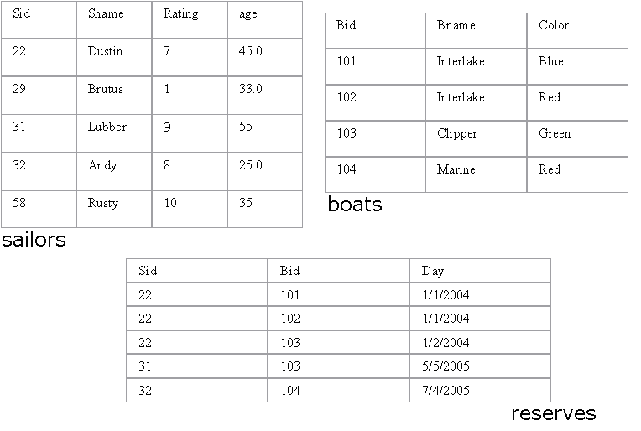

**Write SQL queries for the following:**

**1. Find the names of sailors who have reserved a red boat.**

ANS. select S.sname from Sailors S, Reserves R, Boat b where S.sid = R.sid and R.bid = B.bid and B.color = ‘red’

**2. Find the names of the Sailors who have reserved at least one boat.**

ANS. Select S.name from Sailors S, Reserves R where S.sid = R.sid

**3. Compute increments for the ratings of persons who have sailed two different boats on the same day.**

ANS. Update Sailors set rating = rating*2 where sid =(

select distinct(R1.sid) from Reserves R1, reserves R2 where R1.day = R2.day and R1.bid <> R2.bid);

**4. Find the ages of sailors whose name begins and ends with B and has at least 3 characters.**

ANS. Select age from Sailors where sname like ‘b_%b’;

**5. Find the names of sailors who have reserved a red and a green boat.**

ANS. Select S.sid from Sailors S, Boats B, Reserves R where S.sid=R.sid and R.bid=B.bid and B.color=‘red’ intersect select S.sid from Sailors S, Boats B, Reserves R where S.sid=R.sid AND R.bid=B.bid and B.color=‘green’

**6. Find the sids of all sailors who have reserved red boats but not green boats.**

ANS. Select R.sid from Boats B, Reserves R where R.bid=B.bid and B.color=‘red’ except select R.sid from Boats b, Reserves R where R.bid=B.bid and B.color=‘green’

**7. Find the sailors with the highest rating**

ANS. select * from Sailors S where S.rating >= all (select S2.rating from sailors S2)

**8. Find the name of the oldest sailor.**

ANS. SELECT S.sname FROM Sailors S WHERE S.age = (SELECT MAX (S2.age) FROM Sailors S2)

**9. Count the number of different sailor names.**

ANS. select count(s.name) from sailors group by sname;

**10. Find the no. of sailors who is eligible to vote for each rating level.**

ANS. select count(*) from sailors where age>21 group by sname;

**11. Find the no. of sailors who is eligible to vote for each rating level with at least**

**two such sailors.**

ANS. select S.rating, avg(S.age) as avgage from sailor s where S.age >=18 group by S.rating having 1 < (select count (*) from Sailor S1 where s1.age >= 18 and S1.rating =S.rating)

**12. Find the sid of the sailors who have sailed exactly one boat.**

ANS. select sid from Reserves group by sid having count(sid) = 1;

**13. Find sailors who have not reserved any boats.**

ANS. Select sid from Sailors where sid not in(select sid from Reserves group by sid having count(sid) >= 1);

**14. Find the Sailors who have reserved all the boats.**

ANS. Select S.sname from Sailors s where not exists ((select B.bid from Boats B) except (select R.bid from Reserves R where R.sid=S.sid))

**15. Find all the sailors older than Dustin.**

ANS. select S.sname from Sailors S where S.age > (select S1.age from Sailors S1 where S1.sname ="Dustin");

**16. Find all sailors whose ratings is greater than any others rating without using aggregates like MAX.**

ANS. select sname from Sailors order by rating desc limit 0,1;

**17. Find the sailors with 3rd highest ratings.**

ANS. select sname from Sailors order by rating desc limit 2,1;

**18. Find sids of the sailors who have reserved all the boats reserved by the sailor with sid =’31’.**

ANS. select sid from reserves where bid = (select bid from reserves where sid = 31);

**19. List out all the sailors. For the sailors who have reserved some boats list out the boat’s bids also.**

ANS. select S.sid, S.sname, R.bid from sailors S join reserves R on S.sid = R.sid;

**23. Find the last three customer records inserted. (Refer the above Customer table)**

ANS. select *from customer order by CustID limit 0,3;